Knot Sure – Basic Ropework for Paddlers
This material has been adapted and reprinted with permission from “In the Same Boat,” a weekly column by Tamia Nelson at Paddling.net, the Web's number one source for kayaking and canoeing information. All graphics copyright © 2003-2009 by Verloren Hoop Productions. The full articles can be seen at these pages:

Basic Ropecraft for Paddlers: http://www.paddling.net/sameboat/archives/sameboat200.html
Second String: http://www.paddling.net/sameboat/archives/sameboat219.html
The Versatile Prusik Hitch: http://www.paddling.net/sameboat/archives/sameboat525.html

Definitions

Hitch – a knot that ties a rope to something else
Bend – a knot that ties two ropes together

Three criteria for a good knot
- You can remember it
- It will hold under load
- It can be untied after being loaded
Useful knots for paddling, camping and general use
- Reef (Square) Knot 6. Half Hitch
- Sheet Bend 7. Clove Hitch
- Bowline 8. Tautline Hitch
- Figure-Eights 9. Fisherman’s Knot
- Trucker's (Traveler’s) Hitch 10. Prusik Knot

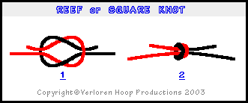
1. Reef (Square) Knot

The reef knot is also known as the square knot. Use it for lashing gear into your boat and tying off bags. Don't use it to join two lines, however; for that, use a sheet bend or fisherman's knot. Make it exactly like the picture. If the two free ("bitter") ends stick out at right angles when you pull the knot taut, you've tied a granny knot, which may or may not hold, and may or may not come apart.

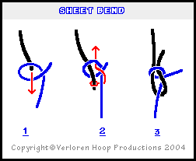

2. Sheet Bend

The sheet bend joins two lines, whether the same size or not. If different sizes, the thicker line (black) should form the bight and the smaller line (blue) should loop around it. If in doubt, wrap the smaller line (blue) around the bight (black) twice before securing. This knot is easy to tie and versatile; however, it can be hard to untie. It reveals the structure of the bowline.

3. Bowline
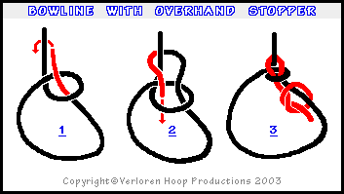
The bowline (pronounced boe-lin) may be the most versatile of all knots. It’s the same knot as the sheet bend but it’s woven rather than looped. It ties and unties easily, holds securely, and doesn’t slip. Use it for painters, boat racks, tarps, etc. The bitter end can be secured with an overhand or stopper knot. Variations are the Brummycham, Eskimo, French, Portuguese, Spanish, double, triple, and water bowlines.

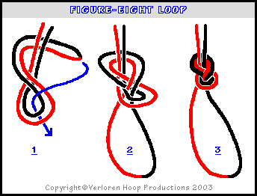
4. Figure-Eights

The only real competition for the bowline comes from the figure-eight loop, which holds well, unties easily, doesn’t jam, is simple to tie, and can be formed with ease anywhere along a rope. The butterfly knot also makes a secure loop that’s easy to untie, but it can be tricky to tie.

The figure-eight knot is a “stopper knot.” It’s tied the same way as the loop, but without doubling the line. It makes a good stopper at the end of a rope for when you want to prevent it from slipping through a hole or eye.

Another secure loop is the (Alpine) butterfly knot (see “Paddle Your Own Canoe” by Gary and Joanie McGuffin, p. 202)
Also: http://www.netknots.com/html/butterfly_knot.html and http://www.animatedknots.com/alpinebutterfly/ and http://en.wikipedia.org/wiki/Alpine_butterfly_knot

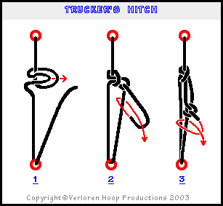
5. Trucker's vs. Traveler’s Hitch

The trucker’s hitch is the usual quick-release knot shown in step 1. Like the simple overhand knot it’s based on, it can be impossible to untie after being loaded. A better knot is the traveler’s hitch, which is formed in a similar way as the trucker’s hitch but with a second twist at the beginning. It’s based on the figure-eight knot and, likewise, it can be untied no matter how much it's loaded. Both hitches function best as a pulley to tighten a line (step 2), such as when tying a boat onto a roof rack or taking slack out of tarp lines. Secure it with a couple of half hitches (step 3). For an illustrated traveler’s hitch, see “Paddle Your Own Canoe,” p. 201.

6. Half Hitch

A single half hitch isn’t very useful by itself, since it tends to come undone. But it’s great for securing other knots. When using a series of half hitches, reverse the direction of the last one to form a clove hitch, which makes it more secure.

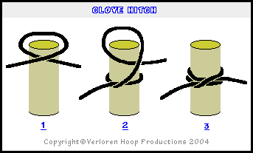
7. Clove Hitch

The clove hitch is easy to tie and untie, and it holds as long as the direction of pull doesn’t change. It’s good for tasks like suspending a clothesline between two trees or lashing two deadfalls together to make a bipod. Don’t use it to moor your boat without securing the bitter (free) end.

Sometimes, though, you have to do more than just tie one on. Suppose you need to pull a sagging line taut, for example, and you want to be able to adjust the tension again later, as the load changes. A trucker's hitch will work here, of course. It multiplies your force, and that can be a big help when you have to tighten a slack line. But the trucker's hitch doesn't always cope well with fluctuating tension, and you often don't need (or want) the mechanical advantage. That's when the tautline hitch comes into its own.

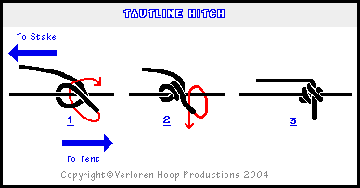
8. Tautline Hitch

The tautline hitch – as its name suggests - is used to take the sag out of a limp line. It may be more commonly used to tension lines that need frequent adjusting, such as tent and tarp guy lines, since it can be slid along the standing part of the rope it’s tied to and will hold again without retying. The tautline hitch works best in light-duty applications and in situations where you'll be adjusting the tension often. If you simply need to get something tight and keep it that way, stick to the trucker's or traveler’s hitch. If you want to make a tautline hitch more secure, make a third turn (repeat step 2) before making the final tuck.

Variations are the rolling hitch and Midshipman’s hitch.

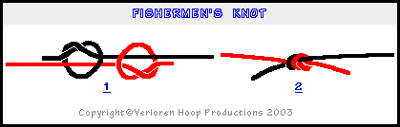
9. Fisherman’s Knot

If you need to join two ropes, you can use a fisherman's knot instead of a sheet bend. Also known as the "waterman's knot," it's very strong and it doesn't often jam. It works best with ropes of equal diameter and construction. You have to tie the knot exactly as shown. If the overhand loops aren't opposed, you'll have a weak link, one that will let you down just when you need it most. This knot is particularly good for making Prusik loops and other forms of the lark’s head knot.

10. Lark’s Head and Prusik Knots

Like the tautline hitch, the Prusik knot slides along another rope or other long object and holds fast under tension. Variations are the double, triple, and extended French Prusiks.

The left-hand picture is a single Prusik. The first time around forms a lark’s head knot, while the second turn creates the Prusik. The middle picture and right-hand pictures show a double Prusik (three times around). The more turns, the more friction and better hold under load.
